The end of the world is nigh, so you should repent while you yet draw breath!

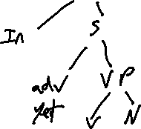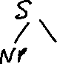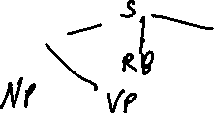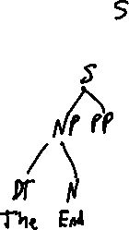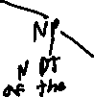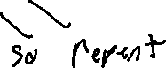

The end of the world is nigh, so you should repent while you yet draw breath!

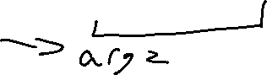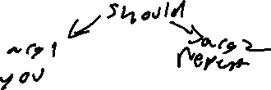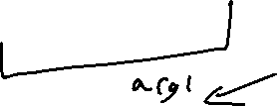

The parse types have advantages in the following ways:  
PSG is the most traditional, it views the structure in the closest method to the traditional academic method that is focused on the clause structure of sentences. It is also probably the easiest architecture to use for generation with a madlib style system.  
Dependencies is perhaps the simplest, but it doesn’t seem to be very useful for a human looking at it, but it;’s structure is a labled graph rather than a value on node system like PSG.